PASSENGER INFORMATION SYSTEM(PIS)

**2014**

RDSO, LUCKNOW

PARTRONICS eBOARDS PVT.LTD, PUNE

7/25/2014

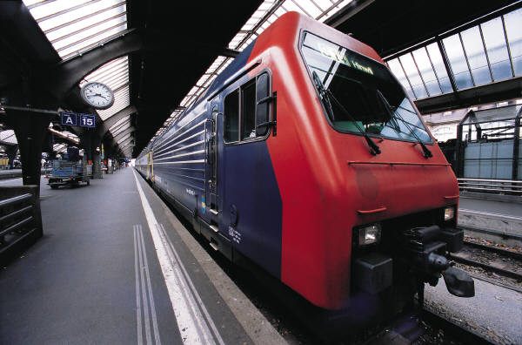

Summary of PIS Display project work (Phase1)

Date: 25/7/1ven in PDF file

I got RDSO documented file of this project from Mr A B Patil sir

Date: 27/7/14

I, More Sir and Dhanashri madam are discussing among us how to do this project.

I read the project and concentrate on command packet format

Date: 28/7/14

I started learning the basics of visual studio and C#, and how to write data on serial port through RS458 standard

Date: 31/7/14

I planned first how command packet format should be then i draw rough command packet structure in my notebook

Date: 2/8/14

I took command packet structure format from pdf file of PIS display and then i immediately started working with command packet format in visual studio

Date: 4/8/14

I created console file to form different types of protocols of PIS (Passenger Information System) and i started writing code for each protocol of command packet.

Date: 7/8/14

I was down with my command packet command packet format code in C#

And then i wrote console program for how to write a data through RS485 standard

Date: 8/8/14

On this day I checked my protocols through console program for PIS on Command window. It is coming correctly then i started implementing CRC (cyclic redundancy check).

Date: 10/8/14

Completed program of CRC (cyclic redundancy check) and check whole packet on PIS display board. In command window packet length calculation is not coming correctly.

Date: 11/8/2014

Correct the program of CRC (cyclic redundancy check) and started working with GUI utility (Graphics user interface) created different types of buttons for different protocols and wrote programs for that buttons

Date: 14/8/14

Done with GUI utility then I started working with Database work for different route. I start trying hardcoding database in GUI utility and check and debug the utility

Date: 16/8/14

Complete my phase 1 of PIS display project and check on PIS single line display board length calculation coming wrong and fed all stations and train name and train number in database

Date: 18/ 8/14

Done with whole PIS project phase 1 and checked on single line PIS display